Jamie Maignan

Processing Tutorial

Step 1: Download “Processing 2.0.3”

For Windows 64 bit click [Here](https://code.google.com/p/processing/downloads/detail?name=processing-2.0.3-windows64.zip&can=2&q=)

For Windows 32 bit click [Here](https://code.google.com/p/processing/downloads/detail?name=processing-2.0.3-windows32.zip&can=2&q=)

For Mac click [Here](https://code.google.com/p/processing/downloads/detail?name=processing-2.0.3-macosx.zip&can=2&q=)

Then click the blue download button to download the zip file. 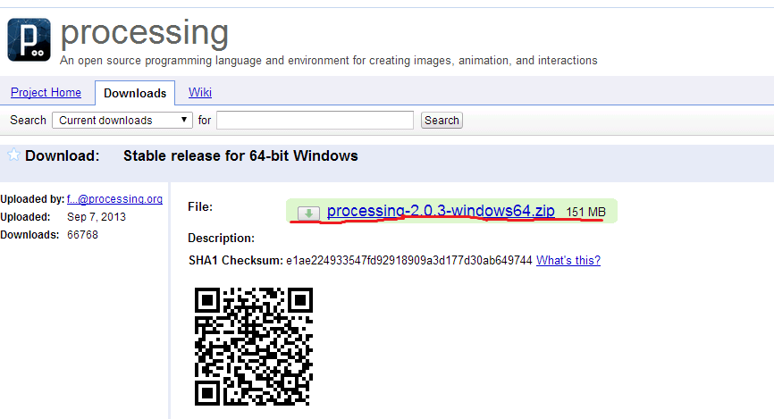

Step 2: Locate and extract the zip file.

(To extract files, you can use programs such as 7zip or Winrar which can be downloaded [Here](http://www.7-zip.org/download.html) and [Here](http://www.win-rar.com/download.html?&L=0))

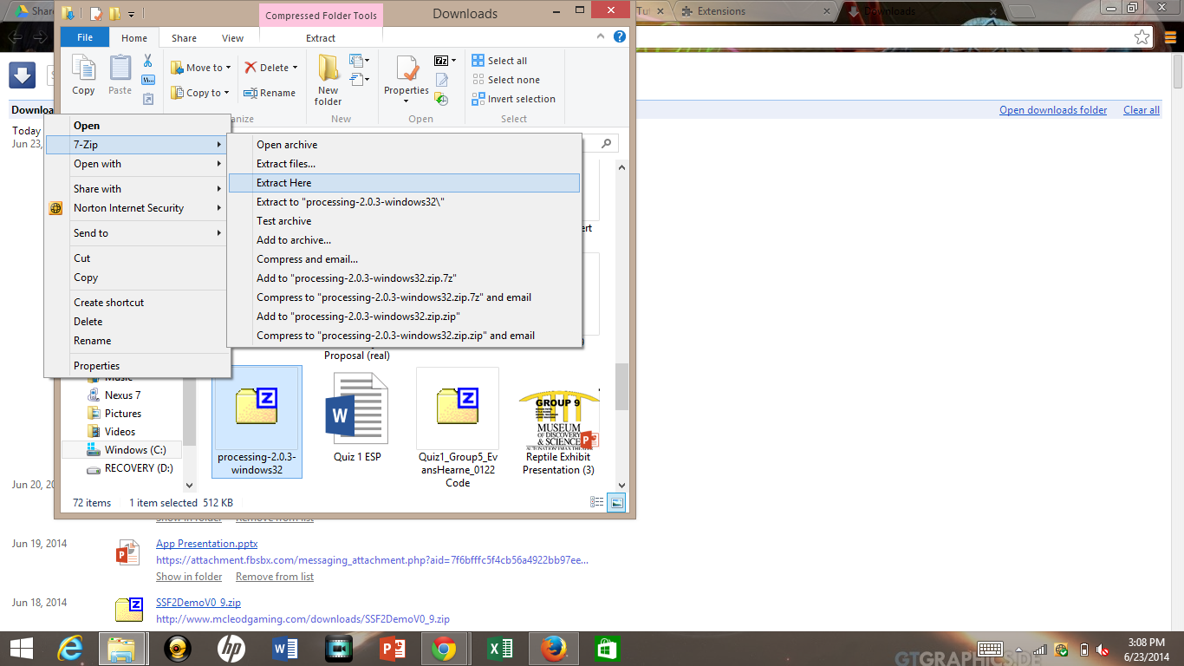

Step 3: Locate the unzipped folder labeled “processing-2.0.3”. Then click the Processing icon and begin.

